**Modelo Entidade-Associação**

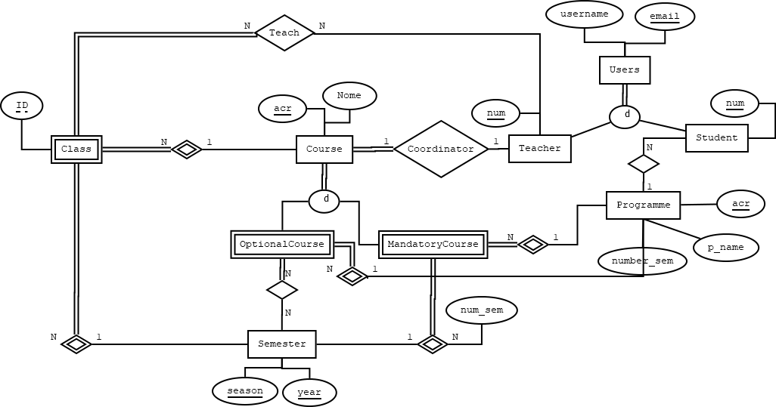

**Modelo Físico**

**Entidades Fortes:**

Users (email, username)

CC = {{email}}

Course (acr,c_name,numCoord)

CC = {{acr}}

CE= {{numCoord}}

numCoord: Teacher (num)

Programme (acr, p_name, number_sem)

CC = {{acr}}

Student (Snum, email,p_acr)

CC = {{num}}

CE= {{email,p_acr}}

Email: Users(email)

P_acr: Programme(p_acr)

Teacher (num, email)

CC = {{num}}

CE={{email}}

Email: Users(email)

Semester (season, year)

CC = {{season,year}}

**Entidades Fracas:**

Optional_course (acr, acrProgramme)

CE= {{acr, acrProgramme}}

Acr: Course (acr)

acrProgramme: Programme(acr)

Mandatory_course (acr,yearSem,season,acrProgramme)

CC= {{acr,year,season,acrProgramme }}

CE= {{year,season,acr,acrProgramme,}}

Year, season: Semester (year, season)

Acr: Course (acr)

acrProgramme:Programme(acr)

Class (id,year,season,acrCourse)

CC= {{id, year, season, acrCourse}}

CE= {{year,season,acrCourse}}

Year, season: Semester (year, season)

acrCourse: course (acr)

**Associações:**

Sem_optionalcourse (acr, yearSem, season, acrProgramme, )

CC= {{acr, yearSem, season, acrProgramme}}

CE= {{yearSem, season,acrProgramme,acr}}

Acr: optional_course(acr)

yearSem,season: semester(yearSem,season)

acrProgramme: programme(acr)

Teacher_class(id,yearSem,season,numTeacher,acrCourse)

CC= {{id,yearSem,season,numTeacher,acrCourse }}

CE={{id,yearSem,season,acrCourse,numTeacher}}

id,yearSem,season,acrCourse: Class(id,yearSem,season,acrCourse)

numTeacher: Teacher(num)